TSA NOTES PART 2

**Q1: Explain Additive model and Multiplicative model?**

**ANS:**

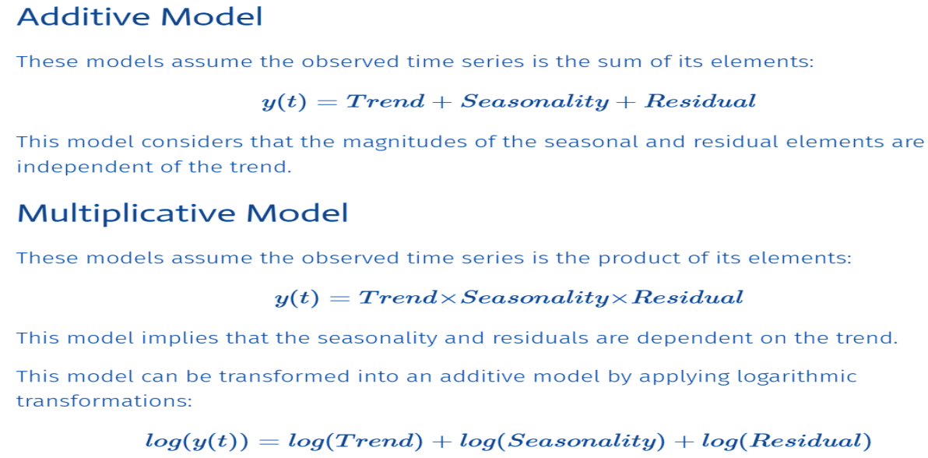

Additive and multiplicative models are two fundamental approaches in time series analysis for decomposing a time series into its constituent components. These components help in understanding and modeling the underlying patterns and variations in the data. The primary difference between the two models is how they represent the relationship between the various components.

**Q2: What is trend? How to remove trend?**

**ANS:**

The trend represent an increase or decrease in time-series value over time. If we notice that the value of measurement over time is increasing or decreasing then we can say that it has an upward or downward trend.

How to remove trend from time-series data?

• **Log Transformation**: To apply log transformation, we need to take a log of each individual value of time-series data.

• **Power Transformation:** Apply power transformation in data same way as that of log transformation to remove trend.

• **local smoothing** - Applying moving window functions to time-series data: We can calculate rolling mean over a period of 12 months and subtract it from original time-series to get de-trended time-series.

• Differencing a time-series.

• **Linear Regression:** We can also apply a linear regression model to remove the trend. Below we are fitting a linear regression model to our time-series data. We are then using a fit model to predict time-series values from beginning to end. We are then subtracting predicted values from original time-series to remove the trend.

**Q3: What is Seasonality? How to remove seasonality?**

**ANS:**

The seasonality represents variations in measured value which repeats over the same time interval regularly. If we notice that particular variations in value are happening every week, month, quarter or half-yearly then we can say that time series has some kind of seasonality.

How to remove seasonality from time-series data?

• **Average de-trended values.**

Average de-trended values is a method for removing seasonality from time series data. It involves the following steps:

• Detrend the time series: This means removing the trend from the data. The trend can be removed using a variety of methods, such as linear regression or polynomial regression.

• Calculate the average of the de-trended values: This gives the average value of the data after the trend has been removed.

• Subtract the average value from the de-trended values: This leaves the seasonal component of the data..

• **Differencing a time series.**

Apply differencing to log-transformed time-series by shifting its value by 1 period and subtracting it from original log-transformed time-series.

**Q4: correlation coefficient?**

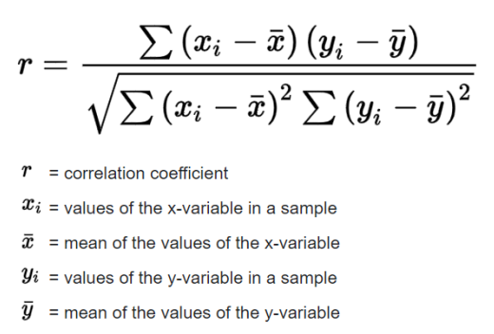

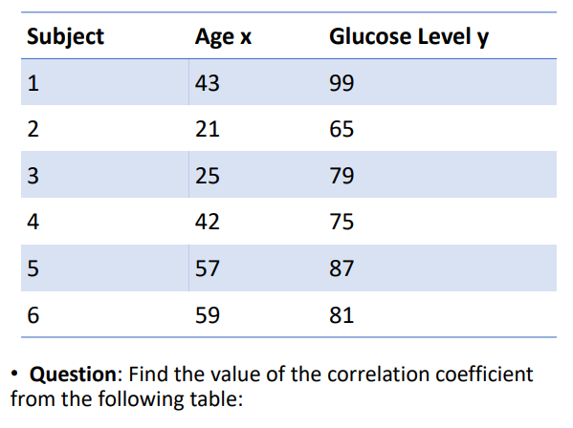

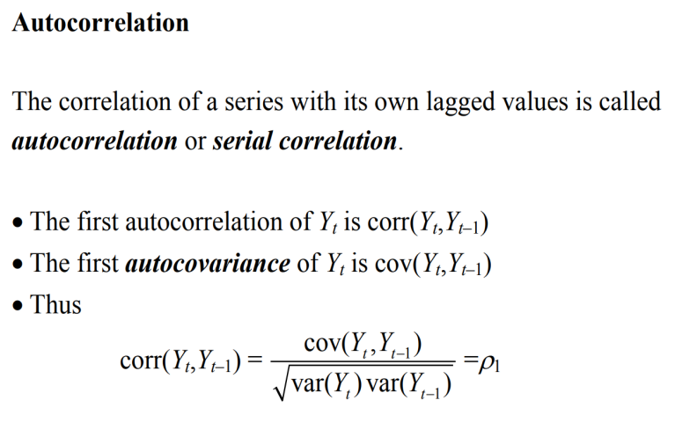

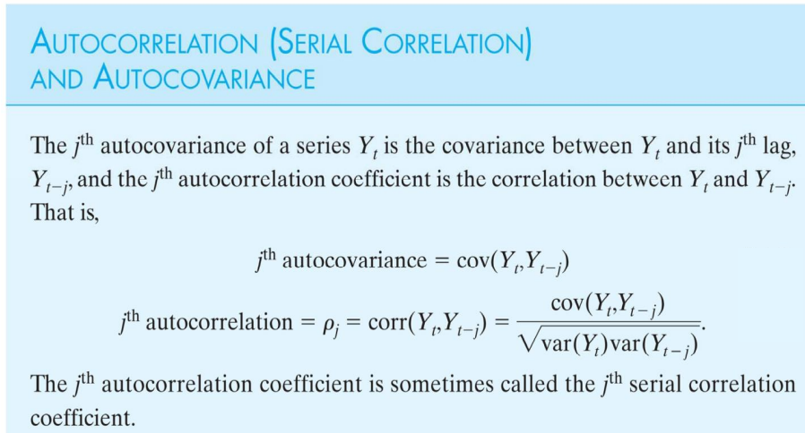

**Q4: Stationary series and Why non-stationary time series data is difficult to analyze?**

**Ans:**

A Stationary series is one whose statistical properties such as mean, variance, covariance, and standard deviation do not vary with time, or these stats properties are not a function of time. In other words, stationarity in Time Series also means series without a Trend or Seasonal components.

Types of Stationary Series:

**Strict Stationary** – Satisfies the mathematical definition of a stationary process. Mean, variance & covariance are not a function of time.

2.**Seasonal Stationary** – Series exhibiting seasonality.

3.**Trend Stationary** – Series exhibiting trend.

• Note: Once the seasonality and trend are removed, the series will be strictly stationary

difficult to analyze:

• Non-stationary data can be more sensitive to noise. This means that small changes in the data can have a large impact on the analysis.

• Non-stationary data can be more difficult to model. This is because the statistical properties of the data are changing over time.

• Non-stationary data can be more difficult to forecast. This is because the future values of the data are not likely to be constant.

Q5: Augmented Dickey-Fuller (ADF) Test.

Ans:

ADF test belongs to a category of tests called ‘Unit Root Test’, which is the proper method for testing the stationarity of a time series.

• In probability theory and statistics, a unit root is a feature of some stochastic processes (such as random walks) that can cause problems in statistical inference involving time series models. In simple terms, the unit root is non-stationary but does not always have a trend component.